Table(s):

**SanMarcos** ( datapoint_id, latitude, longitude, level_of_litter, num_litter_pieces, date_taken )

**ERD**

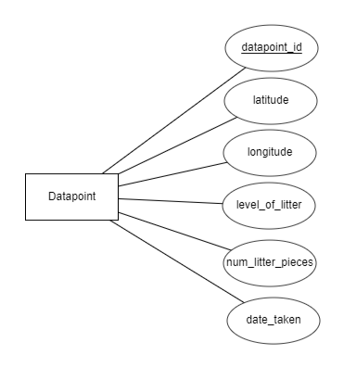

CREATE TABLE SanMarcos (

datapoint_id INT(11) AUTO_INCREMENT,

latitude double,

longitude double,

kab_rank FLOAT,

litter_count FLOAT,

date_taken DATE,

CONSTRAINT datapoint_id_pk PRIMARY KEY(datapoint_id));